1. **Create eks cluster using eksctl**

**During creation, Specify**

* **Cluster name**
* **Kubernetes version**
* **Control plane role**
* **Subnets for Control Plane**
* **Control Plane security Group**
* **Add tag: owner, purpose on Control Plane**
* **Node Group Name**
* **Node Instance Role**
* **Subnets for Node Group**
* **Node Instance SSH key pair**
* **Node Instance Security Group**
* **Node Instance Instance Type**
* **Node Instance Disk**
* **Add tag: owner, purpose on Node Group**
* **Node Group Size: min, max**

Create a security group

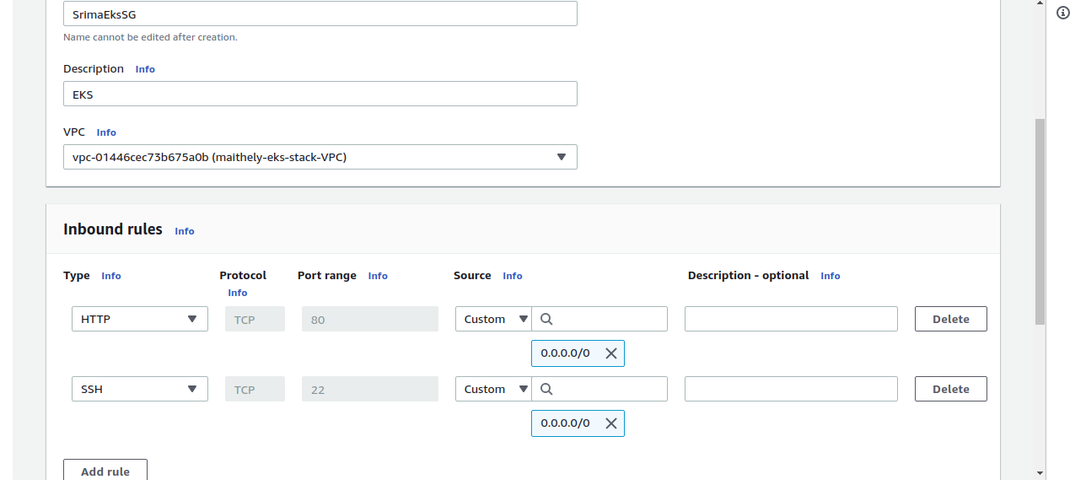

Download eksctl

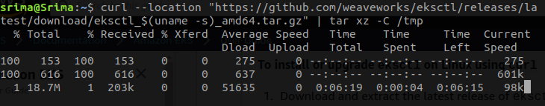

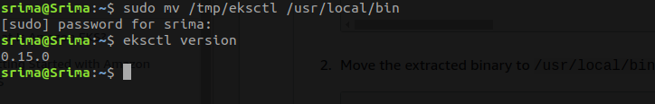

Create a eks role with the following policies

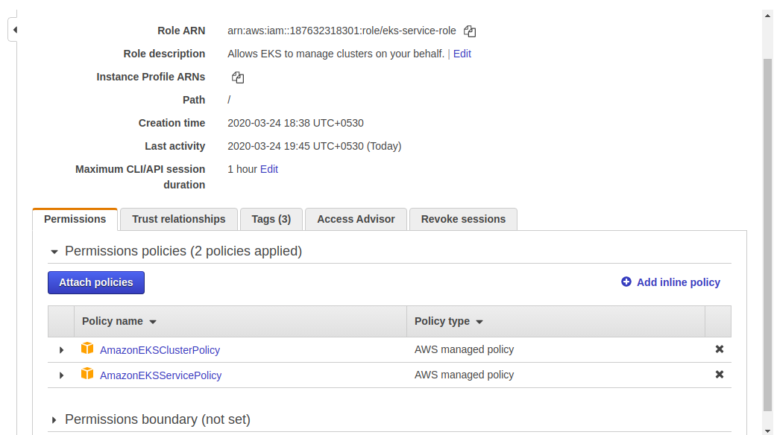

Create another role for ec2 instances with the following policies

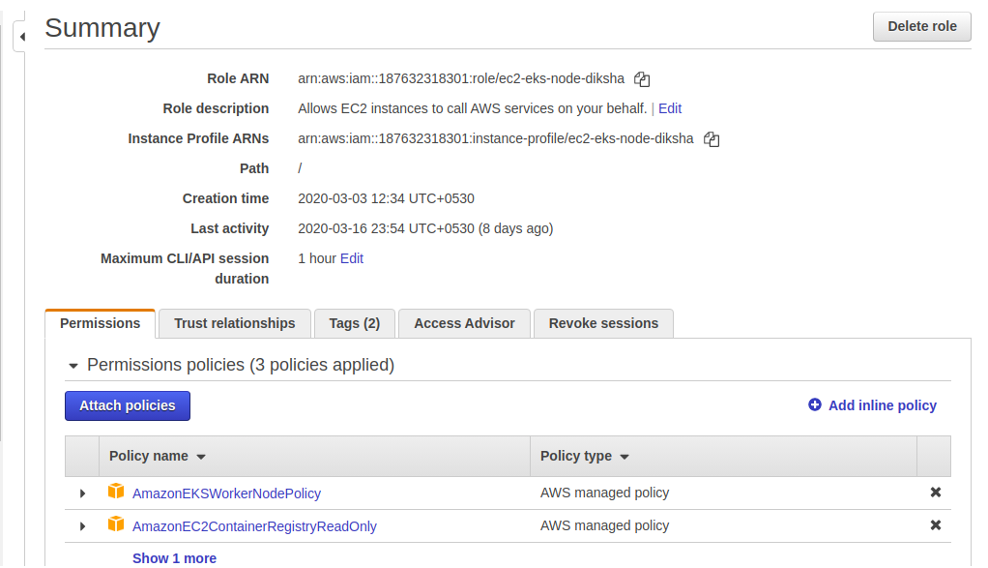

Create eks.yml with all the configuration details

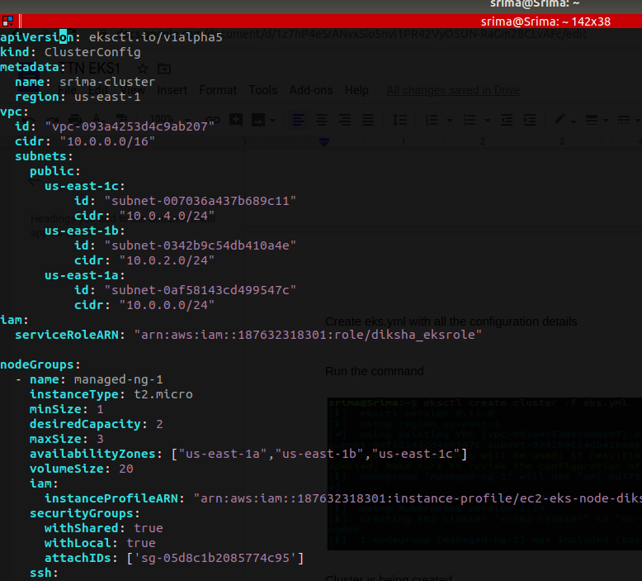

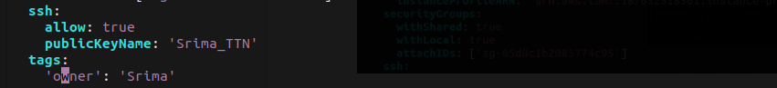

Run the command

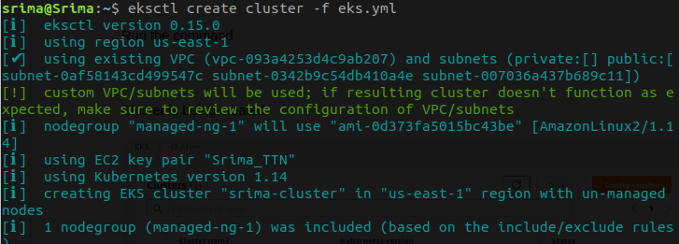

Cluster is being created

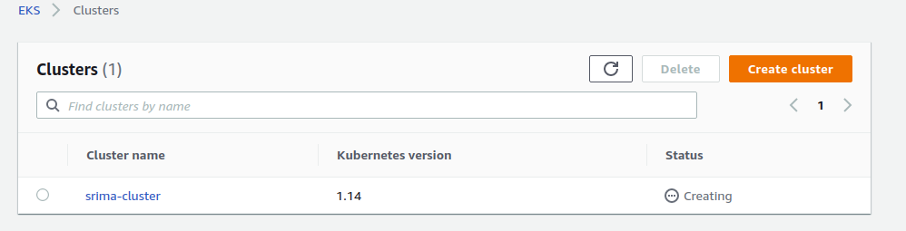

Cluster is ready

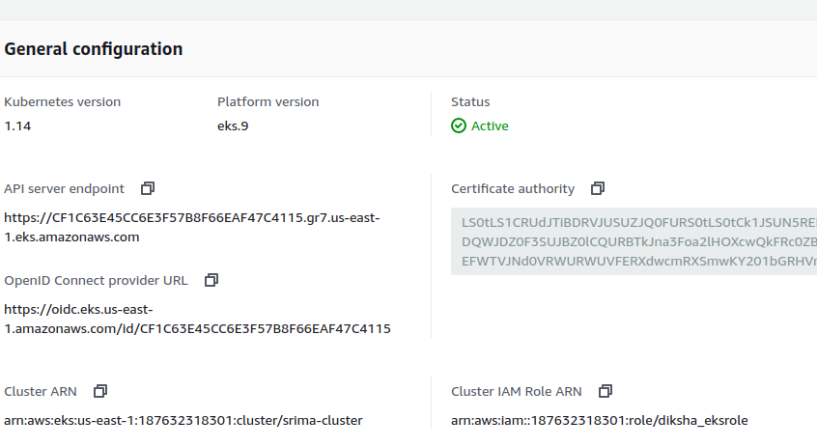

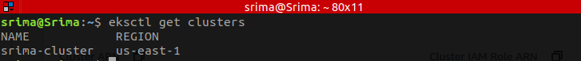

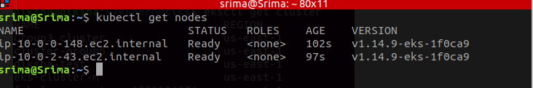

**2.Authentication Management**

* 1. **Add new 1 IAM user into the cluster**



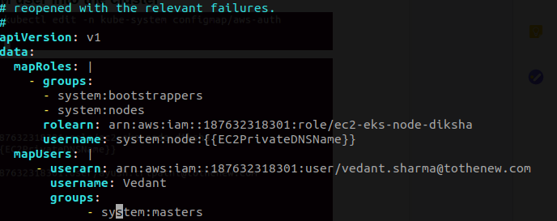

* 1. **Enable an EC2 server to access Cluster master API without using access/secret key**

Create a new policy and specify service EKS

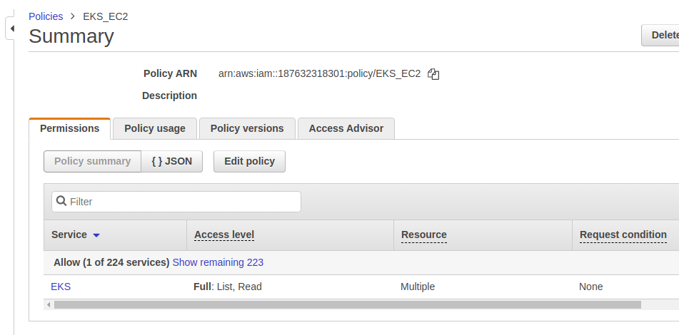

Create a new role and attach the above policy

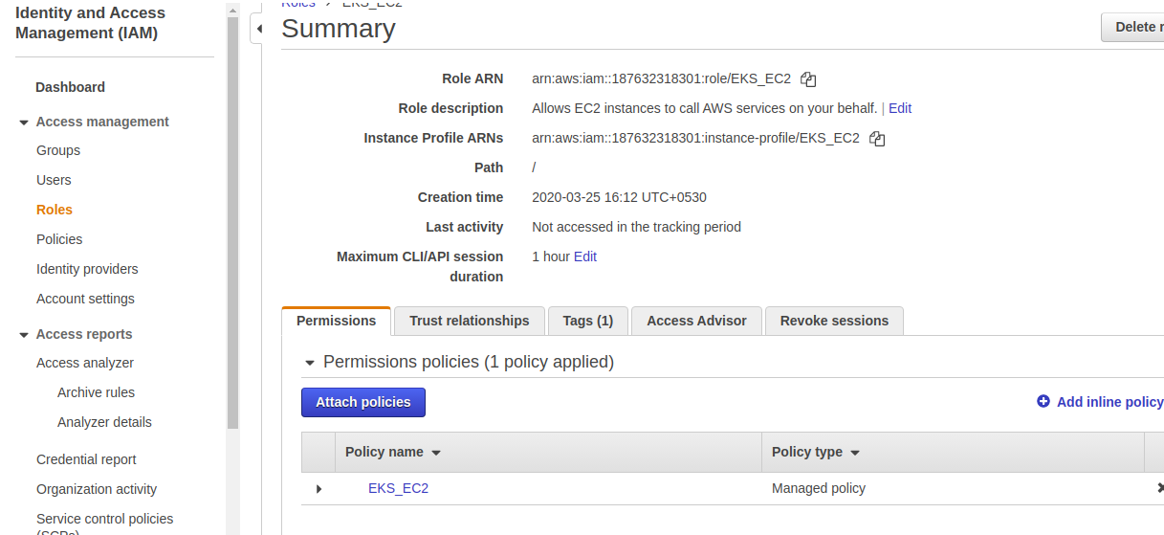

Create an instance and attach this role to that instance

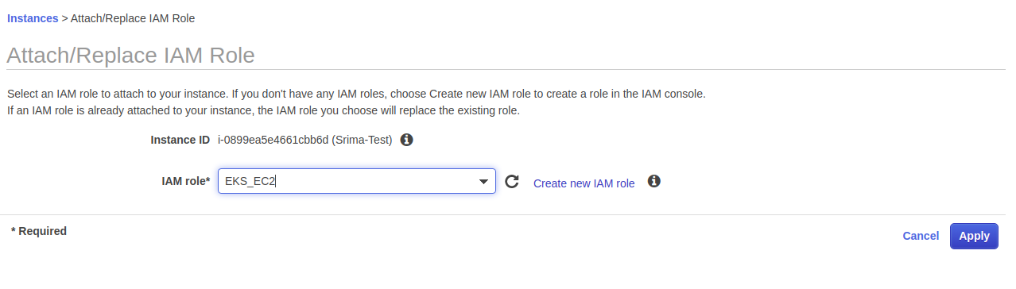

Then run the below command to see the cluster status

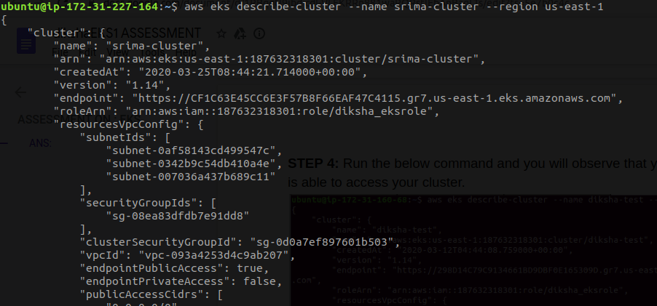

**3. Eksctl command to terminate the stack.**

